SIMATS ENGINEERING (SAVEETHA SCHOOL OF ENGINEERING)
Department of Computer Science and Engineering
CO2 ASSESSMENT TOOL 2 – Architecture Design Assignment

Course Code: | CSA10 / CSA1063 | Course Title: | Software Engineering
CO Assessed: | CO2 | Assessment: | Assessment Tool 2 – Architecture Design Assignment
Weightage: | 20% | Total Marks: | 25
CO2 Statement: | Perform detailed requirements analysis, design scalable architectures, and prioritize features with a focus on cross-disciplinary skills
Student Name: |  | Reg. No.:
Date: |  | Duration: | 60 minutes

Code of Conduct
I G. Akshya (192425132) (Name / Reg No) certify that this submission is my original work and that I have adhered to the guidelines specified for this assessment. I understand that any violation of academic integrity rules will result in disciplinary action.
Signature of the Student:
Annexure A – Architecture Design Assignment
Instructions to Students:
Each student will be assigned an individual software project problem statement. Based on the assigned problem, analyse the system requirements and design an appropriate software architecture by applying software engineering principles. Your submission should demonstrate your ability to select, justify, and evaluate a suitable architectural style.

Question
Based on your assigned problem statement, perform an Architecture Design Analysis and prepare an architecture design report by answering the following questions:

1. Analyze System Requirements
- Study the given problem statement and identify the system objectives.
- Analyze the functional and non-functional requirements that influence the software architecture.
- Identify key quality attributes such as scalability, maintainability, reliability, availability, performance, and security.

2. Select a Suitable Software Architecture
- Select an appropriate architectural style for the proposed system (e.g., Layered Architecture, Client-Server, MVC, Microservices, Event-Driven, Service-Oriented Architecture, Serverless, or Hybrid Architecture).
- Justify why the selected architecture is the most suitable for the given problem.

3. Draw the Software Architecture Diagram
- Design a clear architecture diagram illustrating the overall structure of the proposed system.
- Include all major layers/components, databases, external systems, APIs, and communication mechanisms.
- Use appropriate software architecture notations and labels.

4. Explain Components and Their Interactions
- Describe the purpose and responsibilities of each architectural component.
- Explain how the components communicate and exchange data.
- Illustrate the overall workflow of the system.

5. Discuss Quality Attributes
Evaluate how the proposed architecture addresses the following aspects:
- Scalability
- Security
- Performance
- Reliability
- Maintainability
- Availability

6. Justify Architectural Decisions
- Explain the rationale behind your architectural choices.
- Discuss the trade-offs considered while selecting the architecture.
- Explain how the chosen architecture supports future enhancements, system integration, and long-term maintainability.
Rubrics for Calculation
Evaluation Criteria | Excellent (4 Marks) | Good (3 Marks) | Satisfactory (2 Marks) | Needs Improvement (1 Mark)
System Requirement Analysis | Thoroughly analyses the problem statement, accurately identifies functional and non-functional requirements, and clearly explains quality attributes influencing the architecture. | Analyses most requirements with minor omissions or limited explanation. | Identifies only basic requirements with partial analysis. | Requirement analysis is incomplete, inaccurate, or lacks clarity.
Selection of Software Architecture | Selects the most appropriate architectural style with strong technical justification aligned to system requirements. | Selects a suitable architecture with reasonable justification. | Architecture is partially suitable with limited justification. | Inappropriate architecture selected or justification is missing.
Architecture Diagram and Component Design | Produces a clear, complete, and well-structured architecture diagram with all major components, interfaces, and interactions accurately represented. | Diagram is mostly complete with minor omissions or notation issues. | Diagram includes only essential components and lacks sufficient detail. | Diagram is incomplete, unclear, or technically incorrect.
Component Interaction and Quality Attribute Analysis | Clearly explains component responsibilities, interactions, and thoroughly discusses scalability, security, performance, reliability, maintainability, and availability. | Explains most components and quality attributes with minor gaps. | Provides limited explanation of interactions and addresses only some quality attributes. | Component interactions and quality attributes are poorly explained or missing.
Architectural Justification and Technical Presentation | Provides strong justification for architectural decisions, discusses trade-offs and future enhancements, and presents a well-organized, professional report. | Provides adequate justification with minor gaps; report is well organized. | Limited justification with minimal discussion of trade-offs or future scope; report needs improvement. | Justification is weak or absent; report lacks organization and technical clarity.

Criteria | Mark
System Requirement Analysis | /5
Selection of Software Architecture | /5
Architecture Diagram and Component Design | /5
Component Interaction and Quality Attribute Analysis | /5
Architectural Justification and Technical Presentation | /5
TOTAL | /5

CO2 Assessment tool-2

Architecture Design Report
Project Title: Smart Vertical Farming Automation Platform
Name: -G. Akshya Course Code: -CSA1007
Reg.No: -192425132 Slot: -D

1. System Requirement Analysis
The Smart Vertical Farming Automation Platform automates modern farming using IoT sensors, intelligent monitoring and automation. It continuously monitors environmental conditions, optimizes irrigation and lighting, predicts crop health, generates production reports and sends notifications. The architecture supports real-time processing, efficient resource utilization and future expansion.
- Monitor environmental conditions
- Optimize irrigation
- Predict crop health
- Automate lighting
- Generate reports
- Notify operators

2. Selected Software Architecture
A Hybrid Layered Architecture with IoT integration is selected because it separates the application into independent layers. This improves scalability, maintainability and security while allowing easy integration with cloud services, AI modules and external APIs. It continuously monitors environmental conditions, optimizes irrigation and lighting, predicts crop health, generates production reports and sends notifications.

3. Software Architecture Diagram
Insert the generated professional System Architecture Diagram here. The diagram illustrates the flow of data from IoT sensors through the Edge Gateway, API Gateway, Application Services, AI & Analytics Layer and Database before displaying results on the dashboard and sending notifications.

System Architecture Diagram
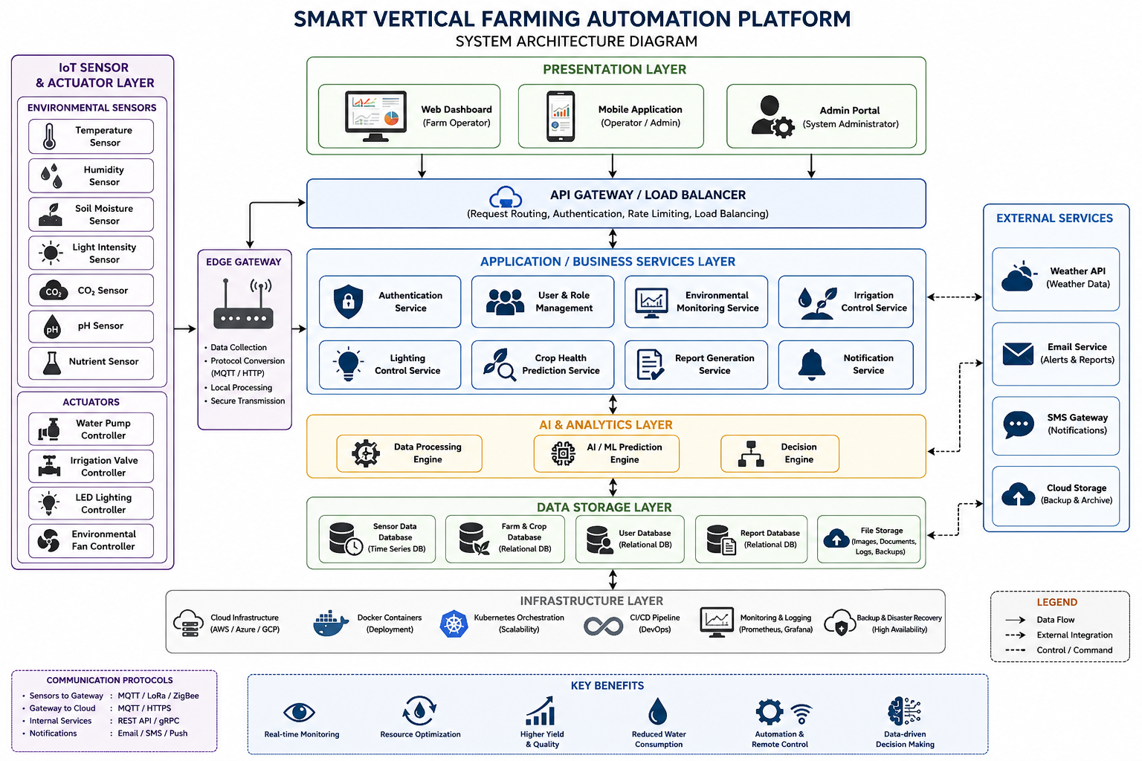

4. Components and Interactions
The Presentation Layer allows users to access dashboards. The API Gateway routes requests securely. Application services process business logic. AI modules perform prediction and decision making. Databases store system information and external services provide weather updates and notifications.
- Presentation
- API Gateway
- Business Services
- AI Layer
- Database
- Notification Services

5. Quality Attributes
The architecture provides scalability through modular services, security using authentication, high performance through optimized processing, reliability with continuous monitoring, maintainability using layered modules and availability through cloud-based deployment.

6. Architectural Justification
The selected architecture supports current project requirements and future enhancements. Its modular design simplifies maintenance, improves integration with IoT devices and allows additional services to be incorporated without redesigning the complete system.
Conclusion
AI modules perform prediction and decision making. Databases store system information and external services provide weather updates and notifications. This improves scalability, maintainability and security while allowing easy integration with cloud services, AI modules and external APIs. It continuously monitors environmental conditions, optimizes irrigation and lighting, predicts crop health, generates production reports and sends notifications.
Code of Content
I G. Akshya (192425132) certify that this submission is my original work and that I have adhered to the guidelines specified for this assessment.
I understand that any violation of academic integrity rules will result in disciplinary action.

Signature of the student: G. Akshya

